ELISTAT PROJECT
Enriching the Lives of Seniors through the Art Therapy
2020-1-TR01-KA227-ADU-097696

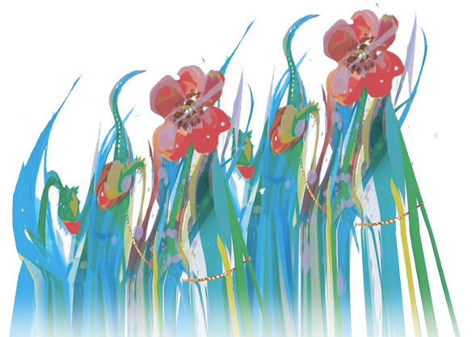
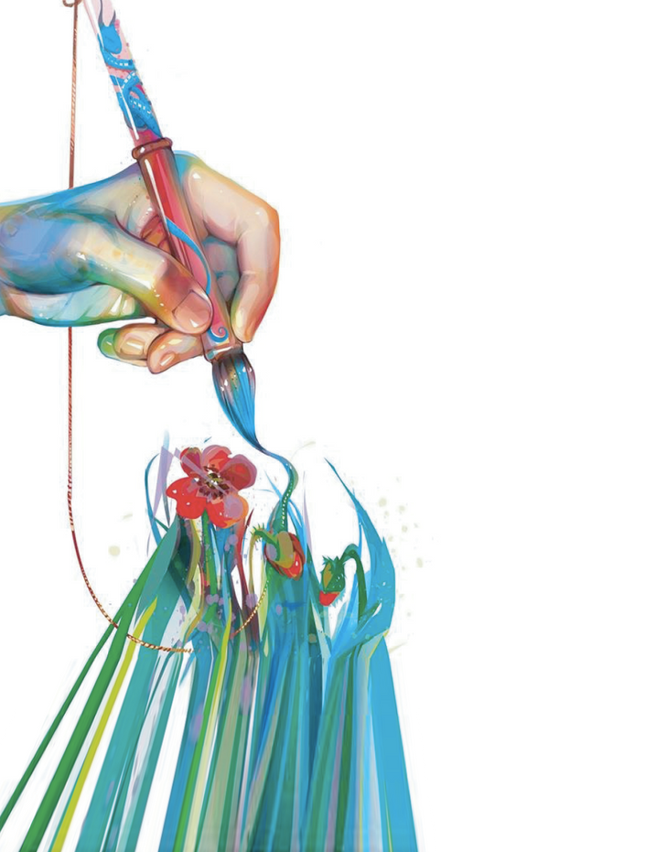
Useful resources and references

Category/ Topic | Link/ Reference | Languages
Articles and practical guidance for general use and for specific types of difficulties | https://arttherapyresources.com.au | English, Arabic, Chinese, Dutch, French, German, Italian
Articles and practical guidance for general use and for specific types of difficulties | M. Corrado, D. Wolf, L. Bills (2022) – Trauma triptych: inviting cross-disciplinary collaboration in art therapy, social work, and psychiatry (International Journal of Art Therapy, 27(4), 169-181, https://www.tandfonline.com/doi/full/10.1080/17454832.2022.2123011) | English
Articles and practical guidance for general use and for specific types of difficulties | European Consortium for Arts Therapies Education (2021) – SATTIE report PHASE 1: Promoting Excellence in Arts Therapies Education at a European level (https://www.ecarte.info/_files/ugd/a16ace_a31c84dcf8714b87ad194a981b5dee74.pdf) | English
Articles and practical guidance for general use and for specific types of difficulties | D. Fancourt, K. Warran, H. Aughterson (2020) – Evidence Summary for Policy: The role of arts in improving health & wellbeing. Report to the Department for Digital, Culture, Media & Sport. UK Gov. (https://assets.publishing.service.gov.uk/government/uploads/system/uploads/attachment_data/file/929773/DCMS_report_April_2020_finalx__1_.pdf) | English
Articles and practical guidance for general use and for specific types of difficulties | D. Sesar (2023) – Art Therapy: Can Art Help Us Heal? (https://www.thecollector.com/art-therapy-can-art-help-heal) | English
Articles and practical guidance for general use and for specific types of difficulties | UK All-Party Parliamentary Group on Arts, Health and Wellbeing (2017) – Inquiry Report (https://www.culturehealthandwellbeing.org.uk/appg-inquiry/Publications/Creative_Health_Inquiry_Report_2017_-_Second_Edition.pdf) | English
Articles and practical guidance for general use and for specific types of difficulties | 100 Art Therapy Exercises, Shelley Klammer: https://intuitivecreativity.typepad.com/expressiveartinspirations/100-art-therapy-exercises.html | English
Articles and practical guidance for general use and for specific types of difficulties | 100 Art Therapy Ideas & Art Therapy Exercises: https://artistro.com/blogs/news/100-art-therapy-exercises-your-path-to-harmony-from-artistro | English
Articles and practical guidance for general use and for specific types of difficulties | 100 Art Therapy Ideas and Prompts: https://www.alternativetomeds.com/blog/art-therapy-ideas | English
Articles and practical guidance for general use and for specific types of difficulties | Elderly crafts: 15 fun projects senior citizens can easily make: https://loaids.com/elderly-crafts | English
Articles and practical guidance for general use and for specific types of difficulties | Nash, J. (2022) – Expressive Arts Therapy: 15 Creative Activities and Techniques: https://positivepsychology.com/expressive-arts-therapy/#techniques | English
Books about expressive arts therapy | Sally Atkins, Melia Snyder (2018) – Nature-based Expressive Arts Therapy (London: Jessica Kingsley Publishers) | English
Books about expressive arts therapy | A. de Botton (2021) – Drawing as Therapy: Know Yourself Through Art (The School of Life) | English
Books about expressive arts therapy | Susan I. Buchalter (2009) – Art Therapy Techniques and Applications (London: Jessica Kingsley Publishers) | English
Books about expressive arts therapy | Susan I. Buchalter (2011) – Art Therapy and Creative Coping Techniques for Older Adults (London: Jessica Kingsley Publications) | English
Books about expressive arts therapy | Susan I. Buchalter (2017) – 250 Brief, Creative & Practical Art Therapy Techniques: A Guide for Clinicians and Clients (London: Jessica Kingsley Publications) | English
Books about expressive arts therapy | J. Campbell et al. (1999) – Art Therapy Race and Culture (London: Jessica Kingsley Publishers) | English
Books about expressive arts therapy | T. Crocker, S.M. Carr (2021) – Clay Work and Body Image in Art Therapy: Using Metaphor and Symbolism to Heal (Routledge) | English
Books about expressive arts therapy | C. Case, T. Dalley (2014) – Handbook of Art Therapy (London/ New York: Routledge) | English
Books about expressive arts therapy | C. Elbrecht (2012) – Trauma Healing at the Clay Field: A Sensorimotor Art Therapy Approach (London: Jessica Kingsley Publications) | English
Books about expressive arts therapy | D.E. Gussak, M.L. Rosal (Eds.)(2016) – The Wiley Handbook of Art Therapy (Wiley Clinical Psychology Handbooks/ Wiley-Blackwell) | English
Books about expressive arts therapy | D. Henley (2002) – Clayworks in Art Therapy: Plying the Sacred Circle (London: Jessica Kingsley Publishers) | English
Books about expressive arts therapy | L.D. Hinz (2019) – Expressive Therapies Continuum: A Framework for Using Art in Therapy (Routledge) | English
Books about expressive arts therapy | S. Hogan (2016) – Art Therapy Theories: A Critical Introduction (London/ New York: Routledge) | English
Books about expressive arts therapy | E.G. Horovitz (2017) – A Guide to Art Therapy Materials, Methods, and Applications (Routledge) | English
Books about expressive arts therapy | J. L. King (2016) – Art Therapy, Trauma, and Neuroscience: Theoretical and Practical Perspectives (New York: Routledge) | English
Books about expressive arts therapy | R. Knishinsky (2022) – Healing with Clay: A Practical Guide to Earth's Oldest Natural Remedy ( Healing Arts Press) | English
Books about expressive arts therapy | Paolo J. Knill, Stephen K. Levine, Ellen G. Levine (2005) – Principles and Practice of Expressive Arts Therapy: Toward a Therapeutic Aesthetics (London: Jessica Kingsley Publishers) | English
Books about expressive arts therapy | L. Leone (2020) – Craft in Art Therapy: Diverse Approaches to the Transformative Power of Craft Materials and Methods (Routledge) | English
Books about expressive arts therapy | Malchiodi, C. A. (2011) – Handbook of Art Therapy (The Guilford Press) | English
Books about expressive arts therapy | Cathy A. Malchiodi (2020) – Trauma and Expressive Arts Therapy: Brain, Body, and Imagination in the Healing Process (Guilford Publications) | English
Books about expressive arts therapy | J. Meyerowitz-Katz, D. Reddick (eds.) (2017) – Art Therapy in the Early Years. Therapeutic interventions with infants, toddlers and their families (London/ New York: Routledge) | English
Books about expressive arts therapy | C.H. Moon (2010) – Materials & Media in Art Therapy (Routledge) | English
Books about expressive arts therapy | S. McNicol, L. Brewster (2019) – Bibliotherapy (Facet Publishing) | English
Books about expressive arts therapy | E. Partridge (2019) – Art Therapy with Older Adults (London: Jessica Kingsley Publishers) | English
Books about expressive arts therapy | L. Scobie (2017) – 365 Days of Art: A Creative Exercise for Every Day of the Year (Hardie Grant) | English
Books about expressive arts therapy | D.E. Waller (2014) – Becoming a Profession: History of Art Therapy 1940-1982 (Psychology Revivals) (London/ New York: Routledge) | English
Books about expressive arts therapy | D.E. Waller (2014) – Group Interactive Art Therapy (London/ New York: Routledge) | English
Articles and practical guidance for specific art therapy techniques and tools – Body Awareness/ Sensorial Activities | https://www.thirstyforart.com/blog/mindful-body-scan-art-therapy | English
Articles and practical guidance for specific art therapy techniques and tools – Body Awareness/ Sensorial Activities | https://digitalcommons.lesley.edu/cgi/viewcontent.cgi?article=1661&context=expressive_theses | English
Articles and practical guidance for specific art therapy techniques and tools – Body Awareness/ Sensorial Activities | https://www.arttherapynj.com/post/increasing-body-awareness-body-outline-in-art-therapy | English
Articles and practical guidance for specific art therapy techniques and tools – Body Awareness/ Sensorial Activities | https://www.mentalhelp.net/stress/emotional-impact/ | English
Articles and practical guidance for specific art therapy techniques and tools – Body Awareness/ Sensorial Activities | https://innergrowththerapy.com/how-art-therapy-uses-the-5-senses-and-helps-to-reconnect-to-the-body/ | English
Articles and practical guidance for specific art therapy techniques and tools – Body Awareness/ Sensorial Activities | https://www.creativehearthealer.com/blog-1/using-your-5-senses-during-art-journaling-to-manage-stress | English
Articles and practical guidance for specific art therapy techniques and tools – Body Awareness/ Sensorial Activities | https://creativityintherapy.com/2016/05/create-a-sensory-self-soothing-kit/ | English
Articles and practical guidance for specific art therapy techniques and tools – Body Awareness/ Sensorial Activities | https://www.artastherapy.ca/art-as-therapy-blog/2016/9/3/stress-and-the-five-senses | English
Articles and practical guidance for specific art therapy techniques and tools – Clay | Clay Ideas and Projects: https://artsyprettyplants.com/air-dry-clay-ideas/ | English
Articles and practical guidance for specific art therapy techniques and tools – Clay | Clay Ideas and Projects: https://www.pillarboxblue.com/easy-air-dry-clay-ideas/ | English
Articles and practical guidance for specific art therapy techniques and tools – Collage | https://creativityintherapy.com/2012/07/collage-art-therapy-part-1/ | English
Articles and practical guidance for specific art therapy techniques and tools – Colouring | https://www.amazon.com/Masterpiece-Coloring-Adult-Stress-Therapy/dp/B01FZCV2U4 | English
Articles and practical guidance for specific art therapy techniques and tools – Creating Puppets and Masks | Bianca Roberts (2023) – The power of puppet therapy helping many aged care residents stay forever young:  https://agedcarenews.com.au/2023/01/24/the-power-of-puppet-therapy-helping-many-aged-care-residents-stay-forever-young/ | English
Articles and practical guidance for specific art therapy techniques and tools – Creating Puppets and Masks | Creating Puppets and Masks for Art Therapy:  https://arttherapyresources.com.au/puppets-masks/ | English
Articles and practical guidance for specific art therapy techniques and tools – Creating Puppets and Masks | How to make Paper Puppets | Easy Puppet Making Ideas | Craft: https://www.youtube.com/watch?v=MQDR5Glz-7E | English
Articles and practical guidance for specific art therapy techniques and tools – Creating Puppets and Masks | How to make a Hand Puppet:  https://www.wikihow.com/Make-a-Hand-Puppet | English
Articles and practical guidance for specific art therapy techniques and tools – Creating Puppets and Masks | How to Build a Quality Puppet:  https://www.instructables.com/How-to-Build-a-Quality-Puppet/ | English
Articles and practical guidance for specific art therapy techniques and tools – Creating Puppets and Masks | https://www.thirstyforart.com/blog/mask-art-therapy-activity | English
Articles and practical guidance for specific art therapy techniques and tools – Creating Puppets and Masks | https://www.twinkl.com.tr/resource/my-inner-self-and-outer-self-portrait-activity-us-he-4 | English
Articles and practical guidance for specific art therapy techniques and tools – Creating Puppets and Masks | https://www.uua.org/re/tapestry/children/windows/session1/143351.shtml | English
Articles and practical guidance for specific art therapy techniques and tools – Creating Puppets and Masks | https://ermer.weebly.com/inner-vs-outer-self.html | English
Articles and practical guidance for specific art therapy techniques and tools – Music Therapy | https://whmusictherapy.com/2011/07/how-are-you-a-song-about-feelings/ | English
Articles and practical guidance for specific art therapy techniques and tools – Music Therapy | https://thriveworks.com/blog/music-therapy-encanto-can-help-process-emotions/ | English
Articles and practical guidance for specific art therapy techniques and tools – Origami | Art Therapy American Association, The Art of Origami: An Art Therapist Explains its History and Use in Trauma Work: https://arttherapy.org/blog-origami-toshiko-kobayashi/ | English
Articles and practical guidance for specific art therapy techniques and tools – Origami | British Origami Society: https://www.britishorigami.org/ | English
Articles and practical guidance for specific art therapy techniques and tools – Origami | Easy origami for beginners: 27 projects to get you started: https://www.gathered.how/papercraft/easy-origami-for-beginners/ | English
Articles and practical guidance for specific art therapy techniques and tools – Origami | Mental health benefits of the practice of Origami/”Improving Life, one fold at a time”: https://origamipulse.com/ | English
Articles and practical guidance for specific art therapy techniques and tools – Origami | Origami Pulse Booklet: https://origamipulse.files.wordpress.com/2019/05/origami-pulse-booklet.-get-started-with-origami.pdf | English
Articles and practical guidance for specific art therapy techniques and tools – Origami | Zhao, F., Gaschler, R., Kneschke, A., Radler, S., Gausmann, M., Duttine, C., & Haider, H. (2020) – Origami folding: Taxing resources necessary for the acquisition of sequential skills (PLoS One, 15(10), e0240226, https://journals.plos.org/plosone/article?id=10.1371/journal.pone.0240226) | English
Articles and practical guidance for specific art therapy techniques and tools – Painting | https://www.linkedin.com/pulse/plein-air-painting-therapy-sarah-pollock?trk=pulse-article_more-articles_related-content-card | English
Articles and practical guidance for specific art therapy techniques and tools – Painting | https://www.sarahburnsstudio.com/life-of-a-wandering-artist-blog/2017/6/22/artists-social-anxiety-1-plein-air-art-therapy | English
Articles and practical guidance for specific art therapy techniques and tools – Painting | https://www.outdoorpainter.com/artists-helping-art-therapy-for-struggling-adults/ | English
Articles and practical guidance for specific art therapy techniques and tools – Painting | https://www.youtube.com/watch?v=pW55JsM3xOo | English
Articles and practical guidance for specific art therapy techniques and tools – Painting | Art Therapy: Paint What You Feel (using Robert Plutchik's wheel of emotions): https://design.tutsplus.com/tutorials/art-therapy-paint-what-you-feel--cms-29956 | English
Articles and practical guidance for specific art therapy techniques and tools – Painting | Therapy Art Worksheets: https://www.therapistaid.com/therapy-worksheets/art/none | English
Articles and practical guidance for specific art therapy techniques and tools – Painting | Top 7 Psychological Benefits of Painting: https://www.flavoursholidays.co.uk/blog/psychological-benefits-of-painting/ | English
Articles and practical guidance for specific art therapy techniques and tools – Painting | S. Mastandrea, S. Fagioli, V. Biasi (2019) – Art and Psychological Well-Being: Linking the Brain to the Aesthetic Emotion. (Frontiers in Psychology, https://www.frontiersin.org/articles/10.3389/fpsyg.2019.00739/full) | English
Articles and practical guidance for specific art therapy techniques and tools – Poetry | https://youngwritersproject.org | English
Articles and practical guidance for specific art therapy techniques and tools – Poetry | https://sanctuarycenters.org/blog/poetry-therapy-guide-to-the-hidden-mind-antidote-to-chaos/ | English
Articles and practical guidance for specific art therapy techniques and tools – Poetry | https://kingdompen.org/the-hidden-art-of-blackout-poetry/ | English
Articles and practical guidance for specific art therapy techniques and tools – Poetry | https://www.youtube.com/watch?v=zf6k8aW2Toc | English
Articles and practical guidance for specific art therapy techniques and tools – Poetry | https://poetrytherapy.org/ | English
Articles and practical guidance for specific art therapy techniques and tools – Poetry | https://www.goodtherapy.org/learn-about-therapy/types/poetry-therapy | English
Articles and practical guidance for specific art therapy techniques and tools – Poetry | Poetry Therapy seminar guide, by Todd Fries: https://toddharrisfries.weebly.com/uploads/5/1/9/9/5199097/poetry_therapy_seminar.pdf | English
Articles and practical guidance for specific art therapy techniques and tools – Poetry | Poetry Therapy: https://www.goodtherapy.org/learn-about-therapy/types/poetry-therapy | English
Articles and practical guidance for specific art therapy techniques and tools – Poetry | Self-Expressive Writing Worksheets: A Collection of PDF’s: https://positivepsychology.com/self-expressive-writing-worksheets-collection-11-pdfs/ | English
Articles and practical guidance for specific art therapy techniques and tools – Poetry | Websites & Organizations of Interest on Poetry Therapy and Bibliotherapy: from the National Association for Poetry Therapy website: https://poetrytherapy.org/Organizations-of-Interest | English
Articles and practical guidance for specific art therapy techniques and tools – Poetry | M. Wexler (2014) – A poetry program for the very elderly. Narrative perspective on one therapeutic model (Journal of Poetry Therapy, 27(1), 35-46, https://www.tandfonline.com/doi/full/10.1080/08893675.2014.871811) | English
Articles and practical guidance for specific art therapy techniques and tools – People and Relationships | Working with conflict through visual mediation – Marian Liebmann:  https://www.academia.edu/64487367/Workshop_Working_with_Conflict_through_Visual_Mediation | English
Articles and practical guidance for specific art therapy techniques and tools – People and Relationships | 6 ways that art therapy can help people with memory loss:  https://lesley.edu/article/6-ways-that-art-therapy-can-help-people-with-memory-loss | English
Articles and practical guidance for specific art therapy techniques and tools – Regression/ Brain Stimulation | https://stats.stackexchange.com/questions/246302/left-hand-right-hand-side-nomenclature-in-regression-models | English
Articles and practical guidance for specific art therapy techniques and tools – Regression/ Brain Stimulation | https://arttherapyspot.com/2012/05/26/non-dominant-hand-ar/ | English
Articles and practical guidance for specific art therapy techniques and tools – Regression/ Brain Stimulation | https://www.psychologies.co.uk/non-dominant-hand-writing-therapy/ | English
Articles and practical guidance for specific art therapy techniques and tools – Soap | April Brown (2018) – Beginner's Guide Natural Soap Making: How to make an all-natural mild and carefully crafted handmade soap | English
Articles and practical guidance for specific art therapy techniques and tools – Soap | Handmade glycerine soap: https://www.youtube.com/watch?v=bxVNyh4ylIc | English
Articles and practical guidance for specific art therapy techniques and tools – Soap | How to Make All-Natural Soap: https://www.greenmatters.com/p/how-to-make-all-natural-soap-homemade | English
Articles and practical guidance for specific art therapy techniques and tools – Soap | How to make glycerin soap: https://www.youtube.com/watch?v=3nwgm5GRDrQ | English
Articles and practical guidance for specific art therapy techniques and tools – Soap | The Benefits of Handmade Soap Made With Natural Ingredients: https://botanicalpaperworks.com/blog/benefits-of-handmade-soap/ | English
Professional associations – American Art Therapy Association | https://arttherapy.org | English
Professional associations – British Association of Art Therapists | https://www.baat.org | English
Professional associations – Culture, Health and Wellbeing Alliance | https://www.culturehealthandwellbeing.org.uk | English
Arts and crafts store online – it provides tools and materials, but also tutorials and ideas | https://www.hobbyland.eu | English, Italian, German, French, Spanish

